AOI Viewer tutorial
- What is AOI Viewer
In brief, AOI Viewer helps auto-picking AOIs and mapping, enable the following intensity and FRET calculation.
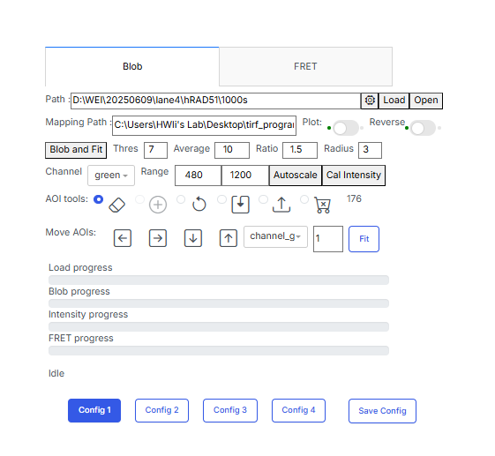
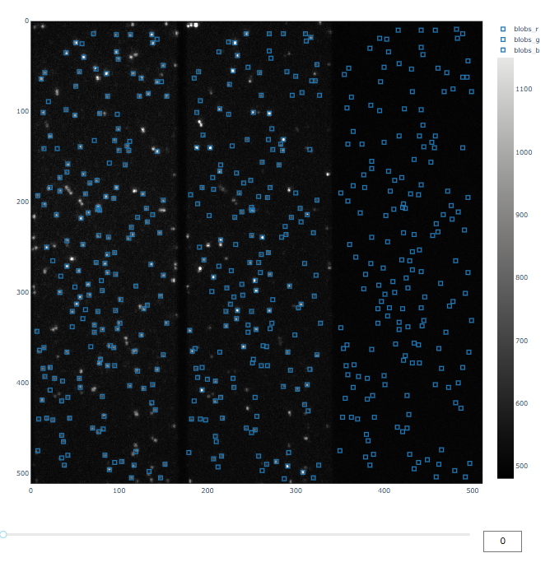
- How to use AOI Viewer
D
E
F
G
H
A
B
C

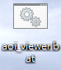
- To use the AOI viewer, click the .bot file “aoi_viewer” on the Desktop.
A webpage will show up and, if the disconnection message shows, press
F5 to refresh the webpage.
- The first step is to open your snapshot file by copying the path of the folder into “Path” in D. You should choose a folder containing sub-folder(s): “r”, “g” or “b” which have .glimpse file in them. After selecting, press “load” and wait for the “Load progress” in G done.
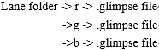
- Your snapshot will be shown in A (without AOI at this time). From left to right are red, green and blue receiving regions. In B, the desired frame can be adjusted here.
If you want to turn the background to white (and the points become black), turn on the “Reverse” in D.
- The next step is auto-picking AOIs. In E, there are multiple parameters to set before blob and fit.
- Thres(Threshold): Set the spot-selecting criteria. AOIs with distance within the threshold will be excluded.
- Average: The final AOI position is the average of [Average] times fitting results. The higher the parameter is set, the longer time auto-picking takes.
- Ratio: Set the criterion for spot shape. If the value of y-axis radius divided by
x-axis radius is greater than “Ratio” for a spot, it is excluded.
- Radius: The size of AOIs.
- Range: Set the spot-selecting criteria. Set the brightness of spot with lowest brightness as lower bound and do likewise for spot with highest brightness. Then demonstrate all spots with above bounds.
The setting depends on the quality of your snapshot. Click “Blob and Fit” and wait for the “Blob progress” in G done.
- After auto-picking, use the AOI tools in F to remove bad AOIs (selecting the eraser).
From left to right, there are functions about removing AOI, adding new AOIs, undo previous action, save AOIs data, load AOIs data, and remove all AOIs. Clicking “label_?” in C can hide or show the AOIs in certain regions
- Next, click “Cal intensity” to calculate the intensity of AOIs. Wait for the “Intensity progress” in G done. Check the selected folder by clicking “Open” in D, there are 2 new folders (“circled” and “raw”), 1 .npz file(“blobs.npz”) and 1 .npy file (dcombined_image.npy) added.
- Go to FRET from the top of D.
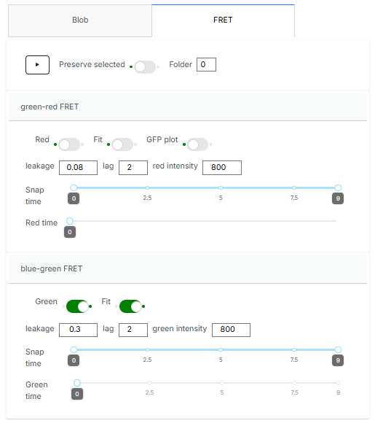
- Before calculating the FRET efficiency, note which FRET(open green-receive red or open blue-receive green) you receive in your assay. For example, if you perform blue -green FRET, setting would be like J.
J
I
- Fit: select what kind of FRET you want to fit(blue-to-green or green-to-red)
- Red /Green: this function is combined with red/green intensity. If an AOI has rr/gg intensity below [red/green intensity], it would be excluded.
(It is useful to pick out those with dead dye(Cy3’/Cy5’))
- Leakage: set the criterion to calibrate the intensity leak out from higher frequency fluoresce.
- Lag: Same as “Average”.
- Snap time and Red/Green time: decide how many frame you want to calculate FRET and filter dead spots.
- After the calculation done, there are 2 new folders (“FRET” and “total_intensity”) added. In the FRET folder, you would find the distrbution graphs of FRET efficiency. In the total_intensity folder, distribution graphs of AOIs’ intensity lie in here.
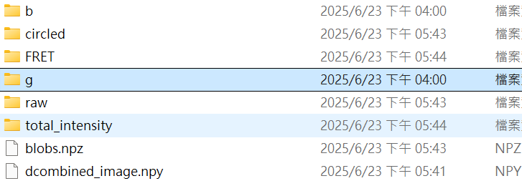

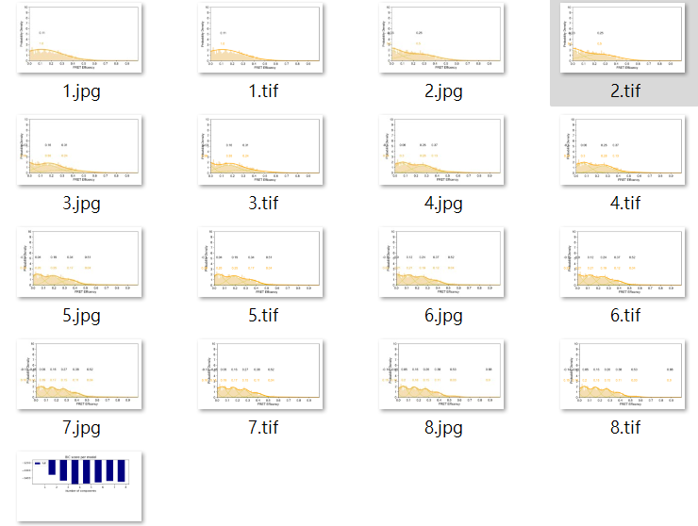
In FRET folder(FRET\0\b):
In total_intensity folder:
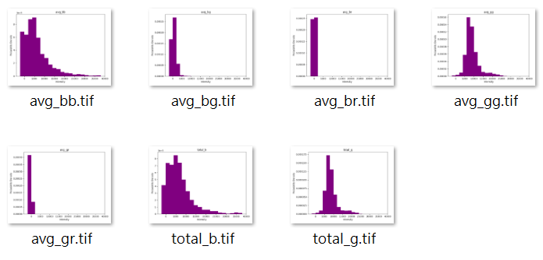
- If you want to keep the setting of parameters, you can click “Save Config” in H for next analysis.
- Update information
In the latest update, we can calibrate the drift of window during long-time experiments.
- Interval: calculating drift per [interval] frames.
- Pairing Threshold: The centers of AOIs with distance within the given parameter would be regarded as the same point.
After clicking the “Calculate Drift ”, the program will perform auto-picking AOIs per [interval] frames. The AOIs are paired depending on “Pairing Threshold” and then calculate average displacement of them. Finally, all frames will be calibrated back to the window without drifting. “Load Drift” can load previous calibration results.

